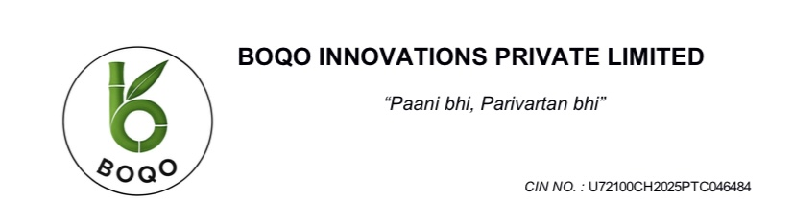

**PROJECT REPORT - BOQO**

**BIODEGRADABLE BOTTLE AND TABLEWARE**

1. **Executive summary**

BOQO is a pioneering sustainable manufacturing venture dedicated to revolutionizing the bottled packaging industry through the production of 100% biodegradable and compostable bottles made primarily from bagasse an agro-industrial by-product of sugarcane processing. In response to growing environmental concerns, plastic bans, and rising demand for sustainable packaging, BOQO offers a viable, scalable, and commercially attractive alternative to petroleum-based plastics.

The technical, financial, environmental, and strategic aspects of establishing a BOQO manufacturing plant with a 10,000 bottle per day starting capacity are described in this project report. Bagasse drying, fiber refining, compounding with PLA and PBAT, preform and blow molding, and rigorous quality assurance testing are all part of the manufacturing process, which aims to satisfy both functional and regulatory requirements.

This report presents a comprehensive roadmap for establishing a BOQO manufacturing facility, encompassing technical process design, site and infrastructure planning, machinery requirements, raw material procurement strategies, quality assurance protocols, packaging considerations, and detailed project economics. It also includes robust financial modeling and market intelligence to assess the project’s commercial potential and scalability.

BOQO is a strategic response to a worldwide ecological challenge, not merely a manufacturing initiative. It is in line with India's national climate change mission, the Sustainable Development Goals (SDGs), and the changing environmental, social, and governance (ESG) standards that both investors and consumers are looking for.

As this report illustrates, BOQO combines innovation, environmental stewardship, and strong market fundamentals. It represents a timely and impactful investment opportunity in the growing green economy — a venture built not only for profit, but for purpose.

1. **Company overview**

BOQO is a visionary sustainability-focused startup in its ideation phase, dedicated to transforming agricultural waste into innovative, eco-friendly consumer products. Conceived with the mission of reducing global plastic dependency, BOQO aims to create 100% compostable, plant-based alternatives to conventional packaging and tableware—starting with biodegradable bottles and molded fiber tableware made from sugarcane bagasse.

At this early stage, BOQO is laying the foundation for a circular business model that leverages renewable, rural-sourced resources and clean manufacturing methods. The idea is built around designing functional, aesthetically pleasing products that are entirely plastic-free, non-toxic, and biodegradable within months—contributing meaningfully to the fight against plastic pollution and climate change.

BOQO envisions becoming a future-ready brand at the intersection of environmental innovation, rural empowerment, and conscious consumerism. With product research, strategic partnerships, and prototype development underway, BOQO is positioning itself as a purpose-driven company ready to scale sustainable solutions for a better planet.

1. **Strategic Overview: The Business Case for Biodegradable Products in India**

**3.1 The Problem: The Plastic Waste Crisis in India**

India, like many nations, faces a mounting crisis of plastic pollution. The extensive and convenient use of plastic has led to its widespread consumption, with almost 1.25 trillion plastic shopping bags used annually worldwide.1 While India's current annual per capita plastic consumption is lower than some global counterparts at around 10 kgs, a projection by the Ministry of Petroleum and Natural Gas indicated this figure would reach 20 kgs by 2022.1 This surge in consumption contributes to an immense volume of plastic litter, which, if left unchecked, is estimated to reach 12 million tonnes by 2050.1

The environmental and public health ramifications are severe. Plastic waste not only pollutes soil, air, and water but also poses direct threats to human well-being. The clogging of sewers by plastic bags can create breeding grounds for mosquitoes and other pests, thereby increasing the transmission of vector-borne diseases like malaria.2 Furthermore, this pollution significantly impacts an already fragile ecological balance, with floods in various parts of the country highlighting the role of plastic waste in exacerbating environmental and infrastructural issues.2 The urgent need for sustainable alternatives to single-use plastics is a clear and present challenge that Boqo Innovations is designed to meet.

**3.2 The Solution: Boqo's Sustainable Product Ecosystem**

Boqo Innovations proposes a strategic solution to this problem through a product ecosystem based on sustainable, biodegradable materials. The company's product lines include tableware made from sugarcane bagasse and bottles and bags made from Polylactic Acid (PLA) and Polybutylene Adipate Terephthalate (PBAT) biopolymers.

Sugarcane bagasse is the dry, pulpy, fibrous material that remains after sugarcane stalks are crushed to extract their juice. It is a renewable byproduct of the sugar industry, making its use in manufacturing a highly sustainable practice that leverages agricultural waste.3 Bagasse-based products, such as plates, bowls, cups, and clamshells, are not only sturdy and capable of withstanding various temperatures but are also 100% biodegradable and compostable.3 These items can naturally decompose into non-toxic elements within 90 days in an industrial composting facility, significantly reducing waste and protecting the environment.3

The bioplastic products, including bottles and bags, will utilize PLA and PBAT. PLA, derived from renewable plant sources like corn and sugarcane, is a significant biodegradable material due to its versatility and utility in both food and non-food applications.5 PBAT is a green, eco-friendly biopolymer that is both flexible and tough, making it an ideal blending resin for other strong but brittle biodegradable polymers.6 This blend is particularly well-suited for manufacturing items like food packaging, films, and bottles.6 These materials are designed to be broken down by microorganisms in composting environments, producing carbon dioxide, water, and biomass, thereby diverting organic waste from landfills and reducing the environmental impact of plastic waste.6

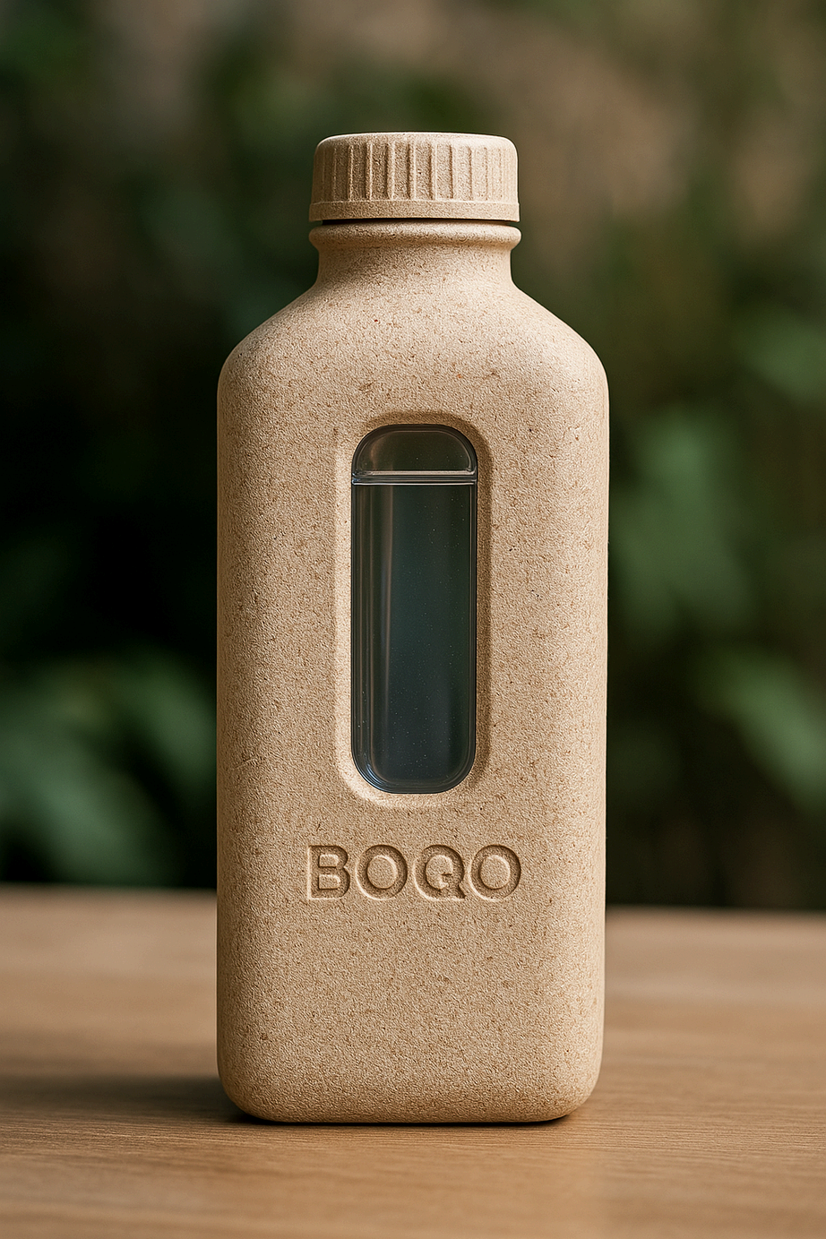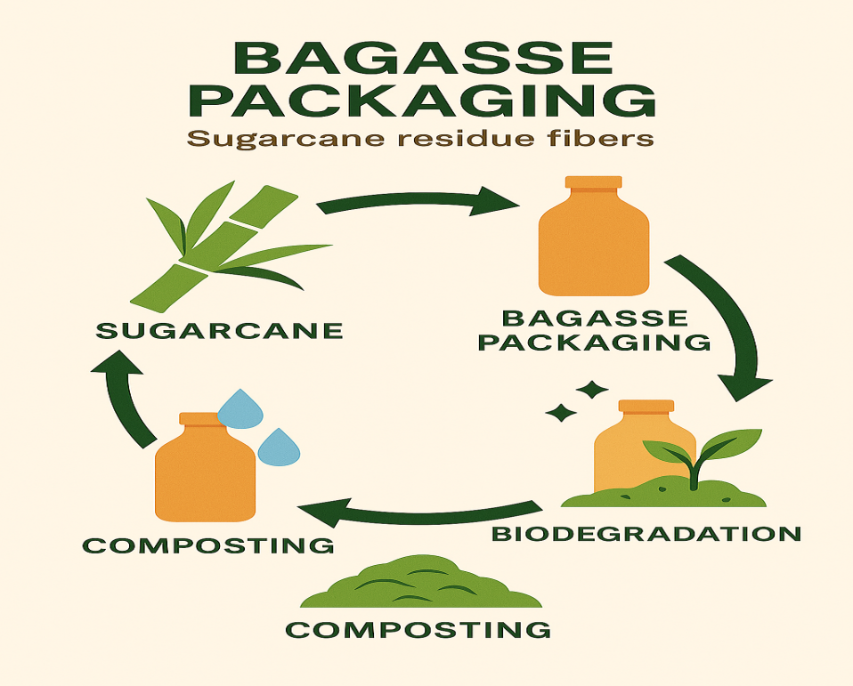

1. **Vision**

BOQO envisions a world where sustainable packaging is not a luxury but the norm — where every bottle, container, and product we create is designed to serve its purpose and then return safely to the earth. Our mission is rooted in the belief that environmental stewardship and industrial innovation can go hand in hand. As we confront the global plastic crisis, BOQO seeks to lead the transformation toward a circular, climate-positive economy, starting with biodegradable bottles made from sugarcane bagasse — a renewable, agro-waste material.

Our vision is to revolutionize the packaging industry by providing scalable, functional, and fully compostable alternatives to single-use plastics. We aim to set new standards in material science and sustainable manufacturing by developing high-performance packaging solutions that are not only eco-friendly but also commercially viable and consumer-friendly. By tapping into the vast potential of biopolymers and green chemistry, BOQO aspires to deliver products that decompose naturally within months, leaving behind no microplastics or toxic residues.

In addition to innovation, BOQO is dedicated to generating socioeconomic value through the incorporation of small-scale industries, farmers, and rural communities into our supply chain. In a bioeconomy, agricultural waste materials like bagasse are transformed into useful, environmentally friendly goods that create jobs, generate revenue, and cut down on pollution at its source. The concepts of zero-waste, regenerative development, and circularity are all strongly reflected in our vision.

1. **Mission of BOQO**

BOQO’s mission is to lead the transition toward a sustainable packaging future by creating high-quality, biodegradable alternatives to single-use plastics. We are committed to transforming agricultural waste — particularly sugarcane bagasse — into innovative, compostable packaging solutions that are practical, scalable, and environmentally responsible.

Our goal is to reduce plastic pollution at its source, promote circular resource use, and empower both consumers and industries to adopt greener practices. Through responsible manufacturing, cutting-edge material science, and collaboration with local communities, BOQO strives to deliver products that combine functionality with purpose — products that serve everyday needs while nurturing a cleaner, healthier planet for future generations.

1. **Core problem we are solving**
2. **Environmental Challenges**

* Reduces single-use plastic pollution through compostable alternatives.
* Minimizes landfill and ocean waste with natural decomposition.
* Converts agricultural waste (bagasse) into eco-friendly packaging.
* Eliminates dependence on fossil fuel-based plastics.

1. **Market & Regulatory Pressure**

* Helps businesses comply with plastic ban laws and eco-regulations.
* Addresses growing consumer demand for truly sustainable packaging.
* Combats greenwashing with certified, genuinely compostable products.

**3. Economic & Operational Gaps**

* Offers scalable and cost-effective biodegradable packaging solutions.
* Creates jobs and rural income through local sourcing and manufacturing.
* Supports a circular, climate-positive economy with low-waste operations.

1. **PRODUCT (DETAIL , PROCESS & APPLICATION )**

**7.1 BAGGASE BOTTLE**

BOQO bottles are an eco-friendly alternative to regular plastic bottles. They’re made using sugarcane waste (called bagasse) along with plant-based materials. Instead of lasting hundreds of years like plastic, these bottles naturally break down within a few months — without harming the environment.

* ***What They’re Made Of:***
* Leftover sugarcane fibers (bagasse)
* Natural plant-based bioplastics (PLA and PBAT)
* No harmful chemicals or toxins
* ***Why They're Superior to Plastic***
* Fully compostable and biodegradable (decomposes in 6–8 months).
* Health-safe—free of toxins and BPA
* Long-lasting, lightweight, and leak-proof
* composed of renewable resources rather than petroleum.
* leaves no microplastics behind.
* ***Environmental Impact***
* Saves plastic from ending up in oceans and landfills
* Turns farm waste into useful products
* Supports local farmers and reduces pollution
* ***Application***
* *Drinking water packaging for environmentally conscious brands*
* *Water service in hotels, resorts, and wellness retreats*
* *Eco-friendly water bottles for conferences, events, and weddings*
* *Water services for railroads and airlines both on board and in flight*
* *Sales at supermarkets, zero-waste shops, and organic stores*
* *University, college, and school green initiatives*
* *Use by government agencies and non-governmental organizations in clean water or plastic-free campaigns*
* ***FORMATION PROCESS***

**1. Raw Material Collection & Preparation**

* Sugarcane bagasse is collected from nearby sugar mills.
* It is cleaned to remove any remaining sugar or dirt.
* The bagasse is then dried to reduce moisture content for pulping.

**2. Pulp Formation**

* Dried bagasse is mechanically shredded into smaller fibers.
* It is mixed with water in a pulping unit to form a slurry.
* Plant-based biopolymers (PLA and PBAT) are blended into the slurry to enhance flexibility, durability, and biodegradability.
* Natural food-safe additives (e.g., organic binders, odor control agents) are added.
* The result is a uniform, moldable pulp mixture ready for forming.

**3. Filtration & De-watering**

* The pulp is filtered to remove oversized particles or impurities.
* Excess water is removed to adjust the consistency and improve moldability.
* The filtered pulp has a creamy texture and is ready for molding.

**4. Molding (Wet Forming)**

* The pulp is poured or vacuum-drawn into a specially designed bottle mold (often a multi-part die).
* Using vacuum suction, the wet pulp adheres to the inner surface of the mold.
* It takes the shape of the bottle as water is extracted through the porous mold wall.
* A preliminary shape is formed, called the “green part” (still wet and fragile).

**5. Hot Pressing / Thermoforming**

* The green bottle is transferred into a heated compression mold.
* Under pressure and temperature (typically 150–200°C), the bottle is compressed and dried.
* This step enhances its strength, surface finish, and dimensional accuracy.
* PLA and PBAT partially melt and act as binders, sealing fibers together.
* The result is a firm, dry, and structurally stable biodegradable bottle.

**6. Trimming & Surface Finishing**

* The edges and seams of the bottle are trimmed using high-precision cutters or CNC routers.
* Any excess material (trimmings) is collected and recycled into the next batch.
* Optional surface smoothing or branding (laser embossing or printing) is done at this stage.

**7. Leak-Proofing (Optional Lining)**

* If needed, a thin inner PLA coating is applied (via spray or dip) to enhance water resistance.
* In some designs, a dual-layer structure with inner biopolymer lining is used.

**8. Drying & Curing**

* The bottle is sent through a controlled drying tunnel or chamber to remove residual moisture.
* This ensures dimensional stability and prevents microbial growth.
* Final moisture content is reduced to 6–8%.

**9. Quality Inspection**

* Each bottle undergoes visual and technical checks for cracks, warping, or weak points.
* Leak tests, compression tests, and surface smoothness are assessed.
* Only defect-free products move to packaging.

**10. Packaging & Labeling**

* Bottles are stacked and packed in recyclable or biodegradable cartons.
* Seed paper tags are attached with it.

**7.2 PLA/PBAT BOTTLE**

## *Polylactic Acid  (PLA)*

## Polylactic Acid (PLA) is a biodegradable polymer derived primarily from renewable resources like corn starch or sugarcane. PLA decomposes into lactic acid through hydrolysis and microbial action under industrial composting conditions. However, its brittleness and relatively low melting point limit its application in certain high-temperature environments.

* PLA is made from renewable resources such as corn starch, and it is commonly used in food packaging, disposable cutlery, and 3D printing
* PLA can break down into water and carbon dioxide in industrial composting facilities.

## *Key Properties:*

* Biodegradable and compostable
* Derived from renewable resources
* Suitable for food packaging, disposable items, and 3D printing
* Limited thermal resistance

## *Poly (Butylene Adipate-Terephthalate) PBAT*

## PBAT is a biodegradable, fossil-fuel-based polymer known for its flexibility and excellent processability. It is often blended with other biodegradable polymers like PLA to enhance flexibility and toughness, making it suitable for applications such as compostable bags, agricultural films, and mulch films. Unlike PLA, PBAT can degrade in various environmental conditions, including soil and marine environments, making it a versatile material for sustainable products.

* Poly(Butylene Adipate-co-Terephthalate) PBAT is a polymer that is used sometimes in combination with starch.
* Efforts are on to produce this polymer from renewable sourc- es. Bioplastics guide sees it as a substitute for LDPE and HDPE.
* It is used to make gar- bage bags, wrapping films, disposable packaging and tableware (Cups, Dishes etc.).
* It is not only biodegradable but also compostable.

## *Key Properties:*

* Flexible and durable
* Can degrade in soil and marine environments
* Typically used in blends with PLA to improve flexibility

These bioplastic will be used to form the preform for blow moulding bottles . Both have their own properties we will be combining both the bioplastic to check whether this combination in compatible or not for making biodegradable bottles .

* ***BLOW MOULDING PROCESS***

**Injection Stretch Blow Moulding (ISBM)** is a two-stage manufacturing process used to create high-precision, hollow bottles. This technique is especially suitable for bioplastics like PLA because it offers better material orientation, clarity, and strength compared to other molding methods. ISBM is ideal for producing food-grade containers such as biodegradable water and juice bottles.

* **ISBM has two main stages:**
* **Stage 1: Injection Moulding (Preform production)**
* **Stage 2: Stretch Blow Moulding (Bottle formation)**
* ***Stage 1: Preform Manufacturing (Injection Moulding)***

1. **Raw Material Preparation**

* PLA resin (pellets) is dried in a dehumidified dryer at 40–50°C for 4–6 hours.
* Drying is essential to prevent hydrolysis (breakdown of PLA) during melting.
* Final moisture content should be <250 ppm.

**2.  Plasticizing & Injection**

* Dried PLA pellets are fed into an injection molding machine.
* The material is heated to 170–200°C, where it becomes molten.
* Molten PLA is injected under high pressure into a precision steel mold to form a “preform” — a thick-walled, tube-like structure with a neck and thread (like a test tube).

**3. Cooling & Ejection**

* The preform mold has internal cooling to quickly solidify the preform while retaining dimensional accuracy.
* Once solidified, the preform is ejected and transferred to the next stage or stored temporarily.
* Note: Preforms can be made at a different time/place and re-heated later for bottle forming (two-stage ISBM).
* ***Stage 2: Bottle Formation (Stretch Blow Moulding)***

**4. Preform Reheating**

* Preforms are reheated using infrared (IR) lamps to the orientation temperature of PLA (approx. 80–100°C).
* Heating is carefully controlled: the bottle body softens for stretching, while the neck remains cool and rigid.

**5.  Stretching & Blowing**

* The heated preform is placed into a bottle-shaped blow mold.
* A stretch rod moves down to axially stretch the preform.
* Simultaneously, high-pressure air (20–40 bar) is blown in.
* The bioplastic stretches both axially and radially, expanding to fill the mold cavity.
* Outcome: The biaxial stretching aligns polymer chains, increasing clarity, impact strength, and barrier properties.

**6. Cooling & Mold Release**

* The mold has cooling channels that quickly solidify the bottle’s shape.
* After 2–4 seconds, the mold opens, and the finished bottle is ejected.

**7. Trimming & Finishing**

* Minor flash or irregularities are trimmed (usually minimal in ISBM).
* Optional: bottle branding, embossing, seed-paper labeling, or QR code application.

**8. Quality Control**

* Bottles are tested for dimensional accuracy, neck finish, leak-proofing, and weight.
* Drop tests, compression tests, and visual inspections are performed.

**9.  Packaging**

* Finished bottles are stacked, wrapped , and packed in recyclable cartons or bulk trays.

**7.3 TABLEWARE**

BOQO Tableware is a line of sustainable, single-use dining products made from agricultural waste — primarily sugarcane bagasse. These products are designed to replace traditional plastic or styrofoam plates, cups, and cutlery with compostable, food-safe alternatives that decompose naturally and safely. The concept is built around environmental responsibility, rural resource utilization, and everyday practicality.

The product line includes a full range of disposable tableware such as plates, bowls, cups, spoons, forks, knives, and food trays. Each item is designed for strength, functionality, and convenience while maintaining a natural, clean look. The tableware is heat- and leak-resistant, making it suitable for hot, cold, dry, oily, or greasy foods. It complies with food safety regulations and can be safely used in both household and commercial food service environments.

Under composting conditions, BOQO tableware will naturally breaks down in 60 to 90 days, leaving no microplastics or hazardous residue behind. Because of this feature, it is perfect for communities and cities trying to meet sustainability goals and cut down on landfill waste. By providing a useful substitute for burning agricultural waste like bagasse, it also helps to lower air pollution.

Target users include restaurants, cafes, catering services, event organizers, food courts, and institutions such as schools and offices. BOQO products are equally suitable for large-scale commercial use and individual consumers who want eco-friendly solutions for home events, travel, or daily use. They will be available in both bulk and retail packaging, with custom branding options for businesses.

* ***Material Details***

***Sugarcane Bagasse (Primary Material)***

* Bagasse is the dry, fibrous residue left after extracting juice from sugarcane stalks.  
  It forms the base structure of BOQO tableware, providing strength, durability, and a natural texture.
* 100% biodegradable, renewable, compostable, and readily available as agricultural waste.
* Environmental Impact: Repurposes farm waste, reduces pollution caused by burning, and supports a circular economy.

***Natural Additives (Food-Safe)***

* Purpose: Added in small quantities to enhance texture, prevent odor, and maintain shape stability.
* Composition: Includes starch-based thickeners, organic anti-fungal agents, and plant-derived colorants if required.
* Safety: All additives used are non-toxic, food-grade, and free from synthetic chemicals.
* ***PRODUCT FORMATION PROCESS***

**1. Raw Material Collection and Cleaning**  
The first step in the process is gathering bagasse, which is the fibrous residue that remains after sugarcane juice is extracted. Usually, sugar mills provide this material. After being gathered, the bagasse is carefully cleaned to get rid of any contaminants like dirt, leftover sugar, or organic matter. This stage guarantees the finished tableware's hygienic and food-safe quality. The bagasse is dried after cleaning in order to lower its moisture content and prepare it for additional processing.

**2. Pulp Formation**  
To create a pulp that resembles slurry, the dried bagasse is first mechanically ground or milled into a finer consistency before being combined with water. In order to increase the pulp's cohesiveness and flexibility, food-safe natural binders may be added at this point. To be moldable and retain strength after forming, the pulp mixture needs to have the ideal ratio of fiber to water.

**3. Molding into Shape**  
In order to define the shape of the tableware item, such as a plate, bowl, or tray, the prepared pulp is transferred into specially made molds. Because of their porous construction and metal construction, these molds enable excess water to escape from the pulp. The pulp is pulled firmly against the mold's surface using vacuum suction or pressure to create the product's initial shape.This soft and wet form is known as the “green part.”

**4. Hot Pressing (Thermoforming)**The molded green part is then transferred to a hot press, where controlled heat (typically 150–200°C) and pressure are applied. This step dries, compresses, and hardens the product into its final form. It also sterilizes the surface and enhances structural integrity, making the item strong, smooth, and heat-resistant. This is a critical step that determines the durability and performance of the tableware.

**5. Trimming and Finishing**  
The product is taken out of the mold and examined after hot pressing is finished. Cutters or fine blades are used to trim any extra fibers or jagged edges. This step may involve branding (such as embossing or debossing a logo), surface polishing, or smoothing. After the product has cooled fully, it may be subjected to a mild UV or heat treatment for added hygienic and shelf-stability benefits.

**6. Quality Inspection**  
Each piece of tableware is subjected to quality control checks to ensure that it meets food safety, strength, and dimensional standards. Items are checked for cracks, deformities, and consistent thickness. Any defective items are separated and recycled back into the pulp batch.

**7. Drying and Packaging**  
The completed tableware is then stacked for packaging after passing through a drying tunnel to eliminate any remaining moisture. To preserve its quality until it reaches the final consumer, it is packaged in recyclable or biodegradable materials and kept out of the moisture.

This entire process is eco-friendly and plastic-free, converting sugarcane waste into compostable tableware that decomposes naturally within 60–90 days after use — making it a sustainable alternative to traditional disposables.

1. **MARKET ANALYSIS**

|  |  |  |  |  |  |  |  |  |  |  |  |  |  |  |  |  |  |  |  |  |
| --- | --- | --- | --- | --- | --- | --- | --- | --- | --- | --- | --- | --- | --- | --- | --- | --- | --- | --- | --- | --- |
| |  |  | | --- | --- | | ****Category**** | ****Details**** | | ****Industry Overview**** | Global bottled water packaging market is valued at **$250+ billion** (2025), with a CAGR of ~6–7%. Growing demand for **eco-friendly alternatives** due to bans on single-use plastics. | | ****Target Market**** | Eco-conscious consumers, urban millennials, students, corporates, hospitality sector, health & wellness enthusiasts, and government bodies supporting sustainable procurement. | | ****Geographical Focus**** | Initial focus: **India (Tier-1 & Tier-2 cities)** → later expansion to **international eco-markets.** | | ****Key Competitors**** | Plastic bottle manufacturers (low cost, high volume) - PET alternatives (PLA, PBAT bottles) - Reusable steel/glass bottles. | | ****BOQO’s USP**** | 100% biodegradable **bagasse-based bottle**, **seed tag for planting**, transparent window, decomposes in **6–8 months**, nature-aligned branding. | | ****Opportunities**** | Rising bans on plastics (India, EU, etc.) - Corporate ESG & CSR initiatives - Green packaging subsidies & government support - Growing demand from **eco-tourism & hospitality**. | | ****Challenges**** | Higher production cost vs PET - Consumer awareness & acceptance - Distribution & scaling - Durability & shelf-life vs plastics. | | ****Market Potential (India)**** | Estimated **₹8,000+ crore eco-packaging market** by 2030. Early adoption in **HORECA (Hotels, Restaurants, Cafés)**, airlines, events, premium retail, and exports. | | ****Threats**** | Price-sensitive Indian market - Entry of global sustainable brands - Supply chain fluctuations in bagasse & biopolymers Misleading “greenwashed” competitors. | |

### Machinery & Equipment Costs

Setting up a manufacturing plant requires significant capital investment in specialized machinery. The cost varies based on the level of automation and production capacity.

**9.1 Bagasse Tableware Machinery:**

|  |  |  |  |  |
| --- | --- | --- | --- | --- |
| **Machines** | **Power** | **Qty.** | **Rate** | **Amount** |
| Beater | 50 HP | 01 | 13,50,000 | **1350000.00** |
| Chest Agitator | 03 HP | 03 | 74,000 | **222000.00** |
| Moulding Machine with 01 VAT 02 HOT PRESS |  | 02 | 25,50,000 | **5100000.00** |
| Trimming Machine | 03 HP | 02 | 1,50,000 | **300000.00** |
| Vacuum Pump | 20 HP | 02 | 2,80,000 | **560000.00** |
| Screw Compressor | 15 HP | 01 | 1,90,000 | **190000.00** |
| UPVC Pipeline with Accessories |  | 01 | 1,70,000 | **170000.00** |
| All Machine Panels and Starters |  | 01 | 2,60,000 | **260000.00** |
| **Total cost (INR)** |  |  |  | **8152000.00** |
| **GST @18%** |  |  |  | **1467360.00** |
| **Grand Total (INR)** |  |  |  | **9619360.00** |

**9.2. Bagasse Bottle Machinery:**

| **Machines** | **Power** | **Qty.** | **Rate** | **Amount** |
| --- | --- | --- | --- | --- |
| Beater | 50 HP | 01 | 13,50,000 | **1350000.00** |
| Chest Agitator | 03 HP | 03 | 74,000 | **222000.00** |
| Moulding Machine with 01 VAT 02 HOT PRESS |  | 02 | 25,50,000 | **5100000.00** |
| Hot Pasting Machine | 01 HP | 01 | 3,00,000 | **300000.00** |
| Trimming Machine | 03 HP | 02 | 1,50,000 | **300000.00** |
| Vacuum Pump | 20 HP | 02 | 2,80,000 | **560000.00** |
| Screw Compressor | 15 HP | 01 | 1,90,000 | **190000.00** |
| UPVC Pipeline with Accessories |  | 01 | 1,70,000 | **170000.00** |
| All Machine Panels and Starters |  | 01 | 2,60,000 | **260000.00** |
| **Total cost (INR)** |  |  |  | **8452000.00** |
| **GST @18%** |  |  |  | **1521360.00** |
| **Grand Total (INR)** |  |  |  | **9973960.00** |

**9.3. PLA Bottle Machinery:**

| **Machines** | **Capacity** | **Cost** |
| --- | --- | --- |
| Laboratory Testing Equipments Chemicals |  | **2,75,000/-** |
| RO Plant (SS 304) | 4000 LPH | **6,75,000/-** |
| UV System | 4000 LPH | **35,000/-** |
| Ozonator | 12 GM | **1,25,000/-** |
| CIP System with Post Filtration Pump |  | **45,000/-** |
| SS Tank 2 | 3000 LTR. | **1,50,000/-** |
| Fully Automatic Filing Machine (WFCL) | 60 BPM | **12,50,000/-** |
| Blow Moulding Machine |  | **11,50,000/-** |
| Batch Coding Machine |  | **2,10,000/-** |
| Shrink Wrapping machine |  | **2,75,000/-** |
| SS Piping & Fitting |  | **1,10,000/-** |
| Sticker Labeling Machine |  | **5,50,000/-** |
| **Total cost (INR)** |  | **48,50,000/-** |
| **GST @18%** |  | **8,73,000/-** |
| **Grand Total (INR)** |  | **57,23,000/-** |

### Plant Layout and Infrastructure

To comply with regulations like those from the Bureau of Indian Standards (BIS) and the Food Safety and Standards Authority of India (FSSAI), the plant layout must include separate rooms for each machine, a change room, a dedicated raw material storage area, and two separate rooms for laboratories.

### 10.1 Raw Material Sourcing and Costs

Boqo's strategic location in Himachal Pradesh necessitates a robust logistics plan for sourcing raw materials.

* ***Sugarcane Bagasse:*** The nearest major sugarcane producing states are Uttar Pradesh and Punjab. The cost of bagasse ranges from ₹2000 to ₹4000 per tonne, depending on the supplier and location. Transporting this material by a Tata 407 truck from a location like Ludhiana to Himachal Pradesh could cost approximately ₹36 per kilometer for a full truckload (FTL).
* **PLA/PBAT Polymers:** PLA/PBAT granules are supplied by manufacturers such as Raghav Polymers in Hyderabad and Konkan Speciality Poly Products in Tiruvallur. Costs for these polymers can range from ₹100 to ₹300 per kg.

**10.2 Other Operational Costs & Requirements**

* **Labor Costs:** Himachal Pradesh has established minimum wages for different worker categories. An unskilled worker earns approximately ₹12,000 per month, while a semi-skilled worker earns around ₹12,690 to ₹12,750 per month. A small plant may employ a manager and a mix of skilled and unskilled workers.
* **Utility Costs:** The average cost of electricity in Himachal Pradesh for 2025-26 is assessed at ₹6.76 per unit. Small and medium industries receive a reduced tariff to provide a thrust to industrialization in the state.The plant will also require a sufficient water supply.
* **Licensing and Certifications:** In addition to business registration, Boqo must obtain a Factory License under the Factories Act, 1948, an Extended Producers' Responsibility (EPR) certificate, and FSSAI and BIS certifications. BIS certification costs include an application fee of ₹1,000 and an annual license fee of ₹1,000 to ₹2,000, in addition to inspection and testing fees. A State FSSAI license costs ₹2,000 to ₹7,500 per year.

## Regulatory and Policy Landscape: A Tailored Justification

The strategic foundation of Boqo Innovations is not just market-driven; it is deeply rooted in and directly supported by India's evolving regulatory landscape. The company's business model is a direct response to a clear and accelerating policy push to eradicate plastic pollution.

### 11.1 *Central Government Directives: A Regulatory Mandate for Change*

The Central Government has taken a definitive stance against single-use plastics (SUP) to promote environmental protection and waste reduction. The Ministry of Environment, Forest and Climate Change notified the Plastic Waste Management Amendment Rules, 2021, which prohibited a list of identified SUP items with low utility and high littering potential starting from July 1, 2022. This includes a ban on plastic carry bags with a thickness less than 120 microns.

A more transformative piece of legislation is the proposed "Single Use Plastic (Regulation) Bill, 2024," which sets a firm target of a complete ban on SUP items by the year 2025.This bill explicitly defines SUP to include "plastic water bottles".This is a game-changing provision that creates a monumental, mandatory market for viable alternatives to conventional plastic bottles. The bill also mandates research by higher education institutions into sustainable alternatives and requires the government to promote their use.

### 11.2 *The Himachal Pradesh Advantage: A Pioneer in Green Governance*

The decision to locate the manufacturing plant in Himachal Pradesh is a strategic masterstroke, leveraging a uniquely stable and supportive state-level regulatory environment. Himachal Pradesh has been a pioneer in environmental governance, with its commitment to controlling non-biodegradable waste dating back to the Himachal Pradesh Non-Biodegradable Garbage (Control) Act of 1995. This long-standing legislative history provides a predictable and low-risk environment, unlike states with more recent or less established policies.

The state's policies provide a direct commercial benefit for Boqo. The total ban on items like "thermocol cups and plates" throughout the state creates a direct, protected, and localized market for Boqo’s bagasse tableware. While the state's "Buy-Back Policy" of non-recyclable plastic does not cover PET bottles, its existence serves as a strong signal of the government's active commitment to waste management and green initiatives.

The confluence of national and state-level policies is the most compelling aspect of this strategic choice. The national ban on plastic bottles creates a vast, nationwide market, while Himachal Pradesh's existing, well-established green policies make it the ideal, de-risked location to set up a compliant manufacturing unit. This convergence is further bolstered by the fact that the challenges hindering the national ban's success, such as a "lack of alternatives" and "un-uniform quality standards" , are precisely the problems Boqo Innovations aims to solve. The company is not just a participant in this market but a strategic asset to the government's broader environmental mission.

1. **Operational Strategy & Geographic Justification**

The choice of Himachal Pradesh for the manufacturing plant and Chandigarh for the corporate office is a deliberate two-city model that balances operational efficiency, strategic positioning, and access to key resources.

**12.1 *Raw Material Sourcing & Logistics***

A key consideration for a manufacturing unit in Himachal Pradesh is the sourcing of sugarcane bagasse, as the state is not a major sugarcane producer. The nearest major producing states are Uttar Pradesh and Punjab, which collectively contribute a significant portion of India's sugarcane output. To address this, Boqo Innovations has a clear logistics plan for procuring bagasse from these states.

The average cost of sugarcane bagasse ranges from ₹2,000 to ₹4,000 per tonne, depending on the supplier and location.The cost of transporting this material from a major producing state to Himachal Pradesh must be accounted for. For a full truckload (FTL) with a capacity of 20 tons, the long-distance rate is estimated to be between ₹25 and ₹40 per kilometer. While this transportation adds to the cost, it is a calculated and strategic trade-off.

The cost incurred from logistics is outweighed by the significant long-term benefits of operating within a stable, pro-green regulatory environment and leveraging the generous state-level subsidies and incentives such as tax holidays, GST refunds, etc. available to manufacturing startups in Himachal Pradesh. The location ensures long-term operational predictability and financial support that is far more valuable than minimizing raw material transport costs. The dual location model, with a commercial office in Chandigarh, provides a perfect hub for managing operations, accessing a skilled talent pool, and serving the wider North Indian market while benefiting from the manufacturing-focused incentives of Himachal Pradesh.

The following table provides a high-level overview of the cost and logistics analysis:

| **Raw Material** | **Source Locations** | **Raw Material Cost (per tonne)** | **Estimated Transport Cost (FTL)** |
| --- | --- | --- | --- |
| **Sugarcane Bagasse** | **Uttar Pradesh, Punjab** | **₹2,100 - ₹4,000** | **Variable, based on FTL rates (₹25-₹40/km for 20-ton truck)** |
| **PLA/PBAT Granules** | **Chennai, Hyderabad** | **₹100,000 - ₹300,000** | **Variable, based on FTL rates (₹25-₹40/km for 20-ton truck)** |

**12.2 *Manufacturing & Operational Plan***

The manufacturing process for bagasse tableware involves pulping the fibrous material and molding it into various products. For PLA/PBAT bottles and bags, conventional plastic processing techniques such as extrusion, injection molding, and blow molding can be used, offering processing versatility. Boqo Innovations plans to adopt efficient, state-of-the-art machinery for both production lines to ensure product quality and operational scalability. The initial operational plan will focus on a phased approach, starting with prototype development and small-batch production before scaling up to meet the high market demand.

1. **Financial Projections and Funding Proposal**

Boqo Innovations' financial strategy is built on a clear understanding of the market, the regulatory environment, and the opportunities for securing government support. The project's financial viability is significantly enhanced by its strategic alignment with various startup incentive schemes.

**13.1. The IIT Ropar TBIF Funding Proposal**

Boqo Innovations is a perfect fit for the IIT Ropar TBIF. The incubator's mission is to empower entrepreneurs with access to "advanced technologies, expert mentorship, and strategic funding" and to nurture "deep tech innovations in key areas such as manufacturing" and "sustainable" solutions. Boqo’s project, with its focus on utilizing advanced biopolymers and sustainable manufacturing processes to solve a national problem, is a direct embodiment of this vision.

The company seeks support under various schemes. These grants are critical for Boqo Innovations to finalize its product designs, conduct pilot manufacturing runs, and secure the necessary technical validation to attract further investment. The funds will be allocated for raw material procurement, specialized equipment for prototype fabrication, and covering initial R&D expenses. Beyond the financial support, a partnership with IIT Ropar TBIF will provide invaluable access to its labs, co-working space, and a network of expert mentors. Further the company needs funds for payout/salaries of our technical person and one assistant.

**PROTOTYPE AND PRODUCT DEVELOPMENT**

|  |
| --- |
|  |

**INITIAL CAPITAL REQUIREMENT (PRE-PRODUCTION STAGE)**

|  |  |
| --- | --- |
| |  | | --- | |  | |

## Financial & Risk Analysis

## 14.1 *Financial Plan and Cost of Project*

A financial plan is crucial for securing funding. A detailed financial analysis must include income projections, expenditures, and break-even points to secure funding from institutions like IIT Ropar TBIF. The total capital investment for a plant depends on its capacity, technology, and location.

The following table provides an estimated breakdown of the project cost for a small-to-medium-scale plant:

| **Particulars** | **Estimated Cost (INR)** |
| --- | --- |
| **Capital Investment** |  |
| **Plant & Machinery (for tableware)** | **₹1 crore** |
| **Plant & Machinery (for bottles)** | **₹1 crore** |
| **Land & Building** | **Owned or Rented** |
| **Miscellaneous Assets** | **₹2-4 lakhs** |
| **Furniture** | **₹1-2 lakh** |
| **Operational Costs (Working Capital)** |  |
| **Raw Materials** | **Varies based on production** |
| **Salary & Wages** | **Varies based on manpower** |
| **Utilities & Overheads** | **Varies based on production** |
| **Total Project Cost** | **₹90 lakhs to ₹2 crore+** |

### 14.2 *Implementation Timeline*

A phased implementation timeline ensures a structured approach to market entry and scaling.

* **Phase 1: Initial Setup & Prototyping (Months 1-6)**
  + Secure funding from IIT Ropar TBIF, leveraging schemes like NIDHI-PRAYAS for prototype development.
  + Finalize plant location and acquire necessary land and infrastructure.
  + Procure and install initial machinery for both product lines.
  + Develop and refine product prototypes for bagasse tableware and PLA/PBAT bottles.
  + Obtain essential licenses and certifications (FSSAI, BIS, Factory License).
* **Phase 2: Production Ramp-up (Months 7-18)**
  + Begin small-batch manufacturing of both product lines.
  + Establish raw material supply chains from states like Himachal, Punjab and Uttar pradesh.
  + Build a local distribution network, focusing on the Himachal and Chandigarh markets.
  + Initiate marketing campaigns and test market response.
* **Phase 3: Scaling & Market Expansion (Months 19-30)**
  + Scale up production capacity based on market demand.
  + Expand sales and distribution to other key markets in North India.
  + Invest in R&D to develop new products and improve existing ones.
  + Pursue larger contracts with cafes, hotels, corporate canteens, and food service providers.

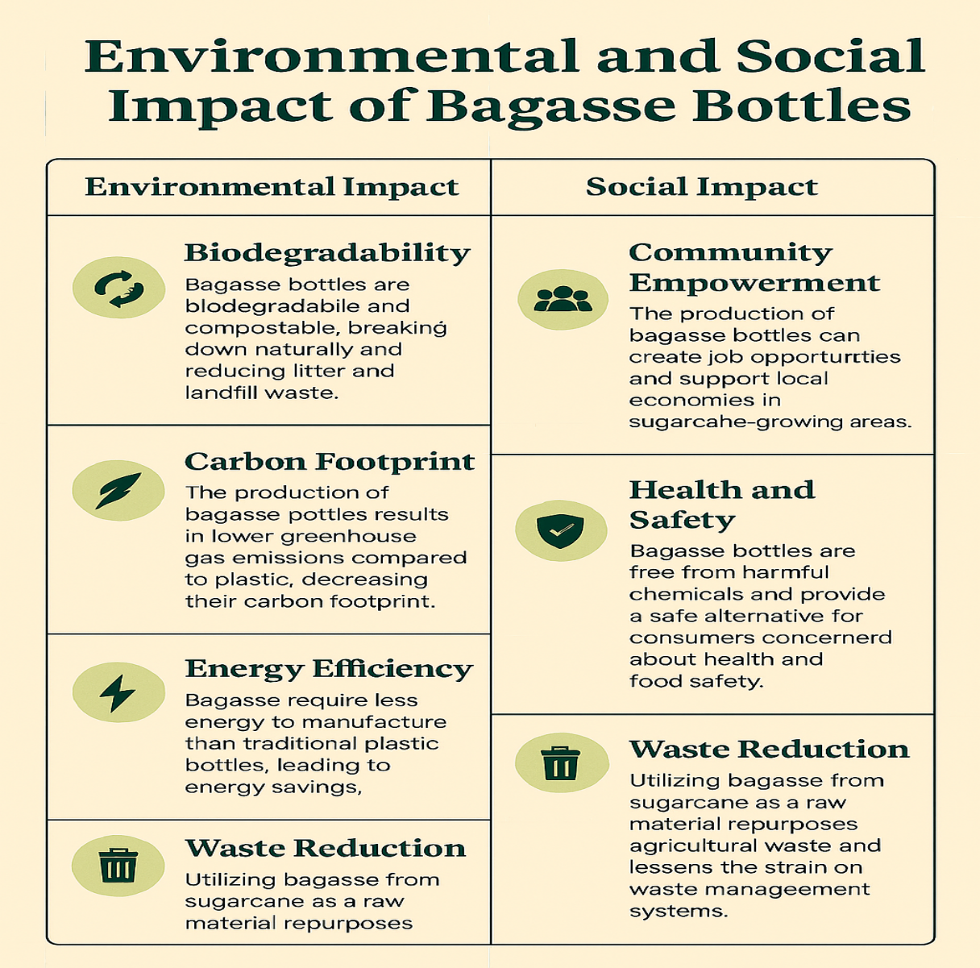

1. **RISK ANALYSIS AND MITIGATION**

|  |  |  |  |  |  |  |  |  |  |  |  |  |  |  |  |  |  |  |  |  |  |  |  |  |  |  |  |  |  |  |  |  |  |  |  |  |
| --- | --- | --- | --- | --- | --- | --- | --- | --- | --- | --- | --- | --- | --- | --- | --- | --- | --- | --- | --- | --- | --- | --- | --- | --- | --- | --- | --- | --- | --- | --- | --- | --- | --- | --- | --- | --- |
| |  |  |  | | --- | --- | --- | | ****Risk Area**** | **Description** | **Mitigation Strategy** | | Moisture Absorption | Bagasse absorbs water, leading to mold and structural weakness. | Apply waterproof coatings; store in dry, humidity-controlled environments. | | Microbial Contamination | Organic material may attract bacteria, fungi, and insects. | Use natural antimicrobial treatments; maintain hygienic production and storage. | | Combustibility | Dry bagasse is flammable and may self-ignite. | Store away from heat sources; monitor temperature in storage areas. | | Chemical Leaching | Residual sugars or acids may leach into soil or water. | Ensure thorough processing; apply food-safe coatings. | | Structural Fragility | Bottles may deform under heat or pressure. | Standardize thickness; conduct durability testing. | | Dust Emissions | Fine particles may affect air quality. | Use dust suppression techniques such as misting and netting. | | Methane Emissions | Anaerobic decomposition can release greenhouse gases. | Maintain proper aeration; avoid over-saturation during composting. | | Pest Infestation | Rodents and insects may infest untreated bagasse. | Use natural repellents; secure storage areas. | | Transport Vulnerability | Bottles may break or deform during logistics. | Reinforce packaging; use cushioning and temperature-controlled transport. | | Consumer Misuse | Lack of awareness may lead to improper disposal. | Include clear labeling; conduct public education campaigns. | | Waste Management Challenges | Improper disposal may contribute to landfill overflow. | Partner with composting programs; offer return or take-back schemes. | |

1. **Unique Selling Preposition**

A bottle that grows after you use it”

Each BOQO bottel carries a second life -a plant waiting to be grown

At BOQO, we wanted to go beyond just reducing plastic - we wanted to give back to nature. so we added a seed tag/seed hanging to our bottle. once the water is consumed the tag/seed can be planted - turning waste into a wildflower/herb/tree. this isn’t just a bottle, its a growing movement

Plantable, Purposeful Packaging

Every BOQO bottle includes a seed tag (like lavender, tulsi, basil) tied to its neck. After use:

* Bury the bottle whole → it decomposes.
* Seed germinates → a tree grows where once there was a bottle.
* One BOQO bottle = less plastic + more oxygen.

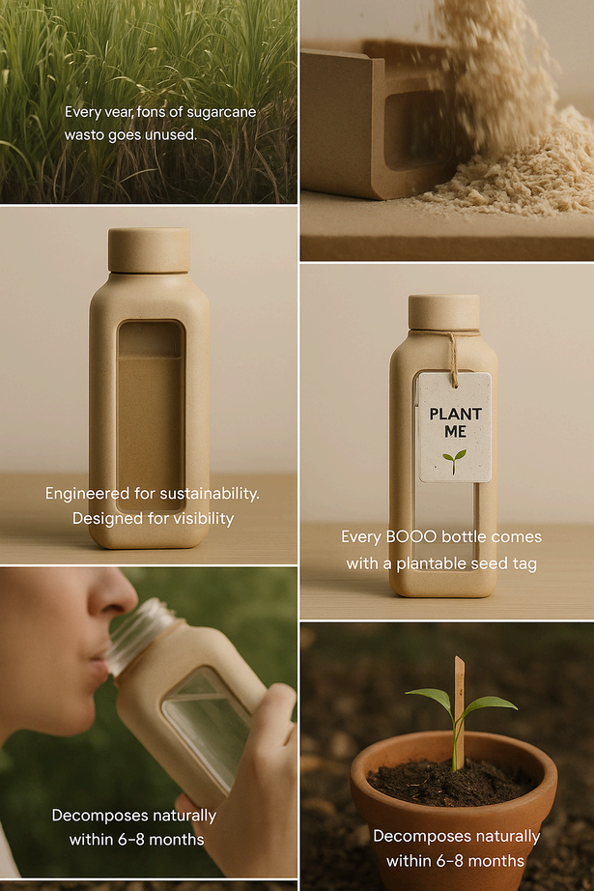

1. **Sample designs of bottle**

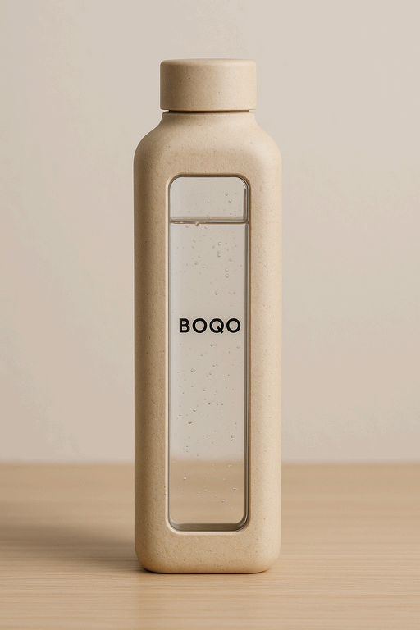 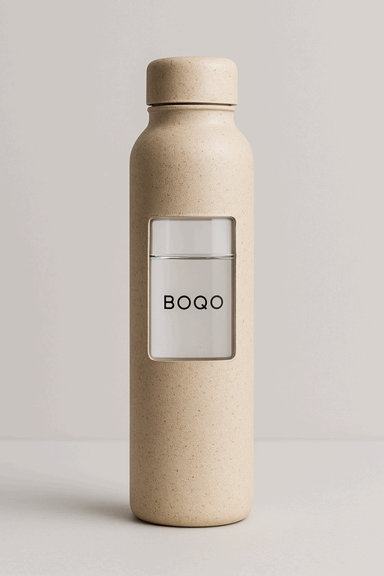 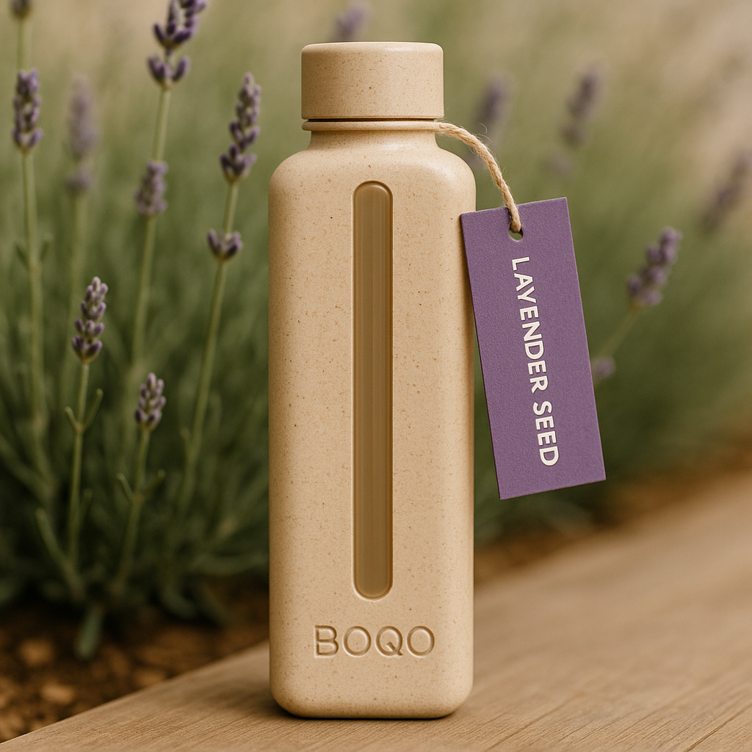 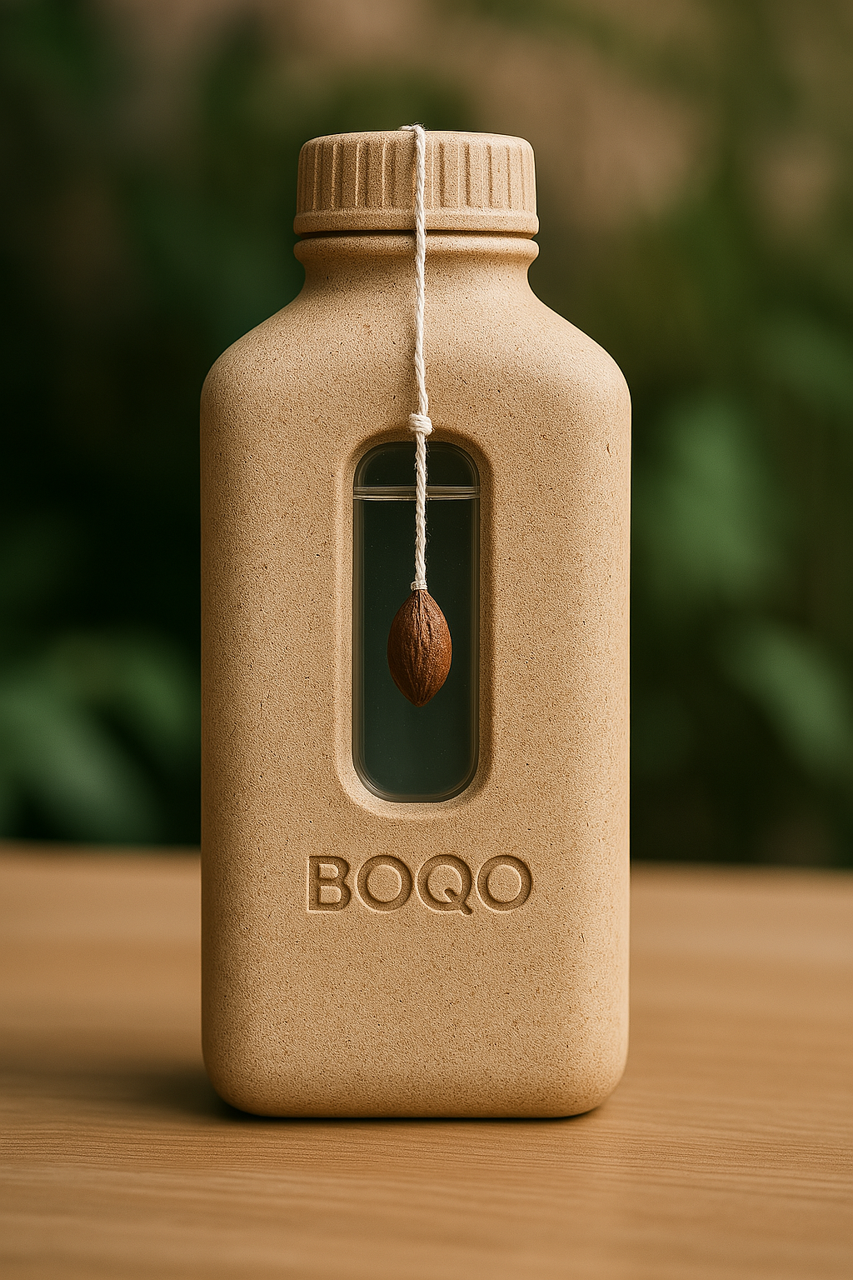

1. **Conclusion**

In conclusion, BOQO represents not just a business opportunity, but a powerful shift toward responsible consumption and environmental innovation. By transforming agricultural waste like sugarcane bagasse into fully compostable packaging and tableware, BOQO addresses pressing global issues—plastic pollution, climate change, and resource inefficiency—through a scalable, circular, and inclusive model.

The detailed analysis of production processes, raw material sourcing, market trends, regulatory alignment, and economic projections demonstrates that BOQO is well-positioned to emerge as a leader in the biodegradable consumer goods space. With a strong vision, sustainable supply chain, and growing demand for eco-alternatives across sectors, BOQO is not only viable but vital for the future of sustainable living.

As we move forward from concept to execution, the roadmap is clear: build responsibly, scale with impact, and lead with purpose. BOQO is more than a product line—it is a call to reimagine everyday essentials in harmony with nature.